

|  |
| --- |
| **PerkinElmer Product Activation** |
| **User Guide** |



|  |  |
| --- | --- |
| **Last Updated:** | February 08, 2022 |

Table of Contents

1 Introduction 3

2 Downloading the Product 3

3 Activation of Product 6

4 Problems with Activation 6

5 Activate by uploading a file 7

6 Trial 8

7 Deactivation of Software 8

7.1 Deactivation from the licensed computer 8

7.2 Deactivation from the online license manager 8

8 Support 10

9 End User License Agreement 11

# Introduction

This guide explains the steps required for downloading any PerkinElmer product, activating a PerkinElmer product, ways to resolve any problems with activation and the steps required to deactivate a product.

# Downloading the Product

On placing an order, you will receive a “**Welcome to PerkinElmer Download Center!**” email at the email ID specified in the order. You need to first create an account to access your software.

To create an account:

1. Click on the **Create Account** button in the email.

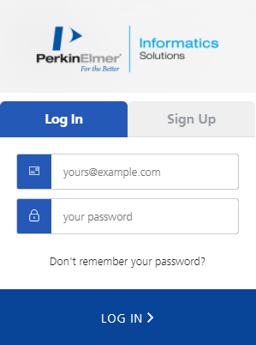

1. Click on the **Sign Up** tab.
2. Enter your email address in the Email Address text box.
3. Enter your new password in the Your Password text box.
4. Click the **SIGN UP** button.

**Note:** If you use the link and find it has expired, or you do not receive the email, just go to the download portal using the following URL and complete starting on step 2

<http://perkinelmerinformatics.flexnetoperations.com/>.

To download the product:

1. Navigate to the Download Center.
2. Login using your **Login ID** (email address) and your **password**.
3. Your page will open onto the “List Entitlements” page. Find the row with your most recent order number (Entitlement ID column), and record the Product Activation code associated with that order.  
   If needed, use the “Help” icon to learn more about the contents of the List Entitlements page you are viewing.   
   Use the “Page” option to scroll through pages if your account has multiple products listed.   
   Use the “Change search scope” drop-down list option or “Advanced Search” if required.

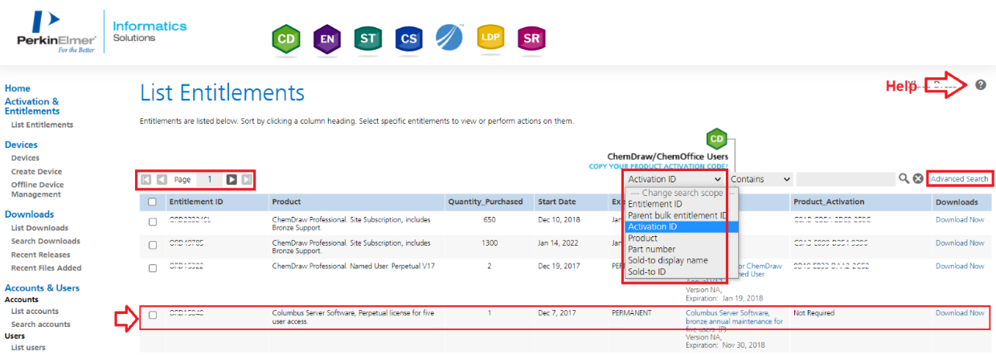

1. For the current order, select the **Download Now** link at the far right-hand column.
2. This will take you to the Download Order page.

**Note**: Your product **Activation Code** is highlighted. Record this code this code to activate your ChemDraw/ChemOffice product.

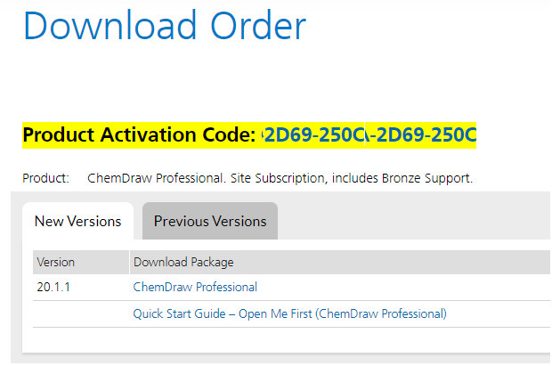

1. To download a current version, use the “**New Versions**” tab. To download an older version, select the “**Prior Versions**” tab.

1. Scroll down the page and select the correct download option for your type of Operating System (Windows or Mac). To start the download, select the corresponding file name from the “**File Name**” column.

# Activation of Product

To activate your product online:

1. In the Activation dialog, enter your name, email address, and activation code in their respective fields.

Activation dialog for Windows: Activation dialog for Mac:

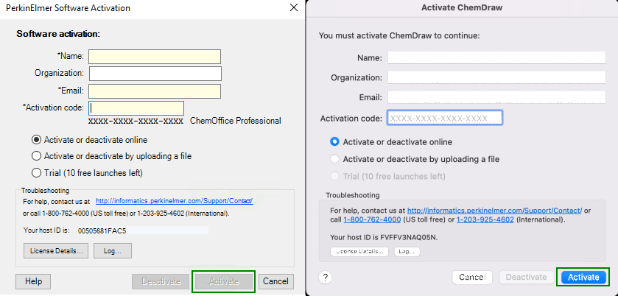

1. Select **Activate**. Upon successful activation, a confirmation message is received.

# Problems with Activation

If activation was unsuccessful, there are several possible reasons:

1. A firewall may be blocking access to the activation server.  If possible, temporarily disable your firewall and then try the activation again.
2. You may need to whitelist the following Flexera activation server website: <https://perkinelmer.flexnetoperations.com/control/prkl/deviceservices>.
3. Your computer may need to install an SSL certificate.  You will get a special message with a solution to this problem directing you to our website- <https://perkinelmerinformatics.flexnetoperations.com>.  Simply visiting the site will provide you with the certificate.
4. You might not be connected to the internet.  If so, try again after reconnecting to the internet.
5. The activation server might be down or temporarily busy.  In this case, try again later.
6. If you are still experiencing issues, please contact your technical administrator or internal IT support representative.

If the online activation failure persists, you can choose one of the alternative activation methods described in Section 6 below.

Activation dialog for Mac: Activation dialog for Windows:

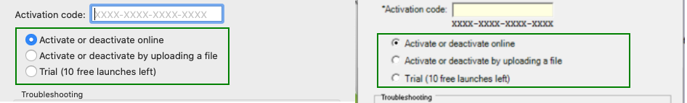

# Activate by uploading a file

You can also activate the software by uploading a .BIN file. To do so:

1. Select the "**Activate or deactivate by uploading a file**" under More Options and click on the "**Activate**" button.  You will be prompted to save a local .BIN file to some location you choose (e.g., your Desktop).  Make sure you fill out the required fields first, including the activation code. Then close the Activation Dialog.  Continue installing the software to completion, if you haven't done so already.
2. Navigate to the following website: <https://perkinelmerinformatics.flexnetoperations.com> and log in.  If you have never logged in, create an account using your organization’s email address. Once logged in, select " **Devices>Offline Device Management** ".    
   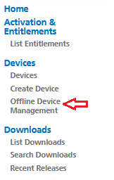
3. Select the "**Generate license**" option, click Browse and navigate to your .BIN file and then select "**Open**". Then select "**Upload**" to upload this .BIN file.

1. A message will appear at the top, click on it to download then new license file

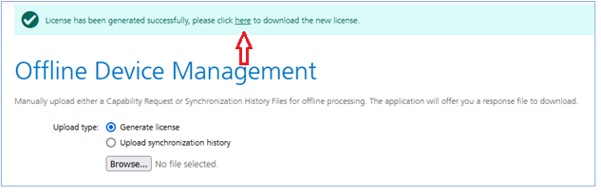

1. Rename the “capabilityResponse.bin” received to “Response.bin”
2. The “Response.BIN” file should be placed in the folder (for example for v21):  
   C:\ProgramData\PerkinElmerInformatics\FNE\21.0 (for Windows) or /Users/Shared/com.perkinelmer.chemdraw.21/FNE (for Mac) on your hard drive.  Then re-launch the software to activate the product.

**Note:** For better results activating the software in a Windows computer, right-click the ChemDraw icon and select “**Run as Administrator**”.

# Trial

If you choose not to activate now (or are unable to because of a firewall or lack of an Internet connection etc.), you have ten[1] free launches of the product available before activation is required.

To activate the trial version:

1. Select the "**Trial**" option.
2. Click on the "**Activate**" button to continue.

# Deactivation of Software

Each time you activate, a license is obtained to use the software for your computer.  You can move the licenses to other computers.  However, you will need to deactivate the software on the currently licensed computer before activating it on another.  This operation is especially important if only a few license seats have been purchased.

## Deactivation from the licensed computer

You can choose to deactivate by selecting either "**Activate or Deactivate online**" option or "**Activate or deactivate by uploading a file**" option.  Follow the steps mentioned above for activating the product and click "**Deactivate**" instead of "**Activate**".

## Deactivation from the online license manager

1. Find the **Host ID** of the computer to be deactivated from the Activation Dialog of the machine.
2. Log on to the Download center [**https://perkinelmerinformatics.flexnetoperations.com**](https://perkinelmerinformatics.flexnetoperations.com).
3. On the left pane under "**Devices**" click "**Devices**". The Search Device page appears.
4. Click the Host ID or use the search option on the top-right corner. You can search by Device Name (email address) or Device ID (Host ID)

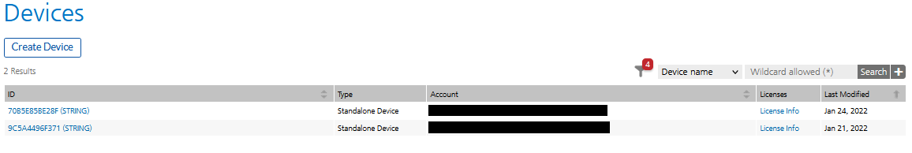

1. From the Device screen, select the Action drop-down menu and click on Remove License

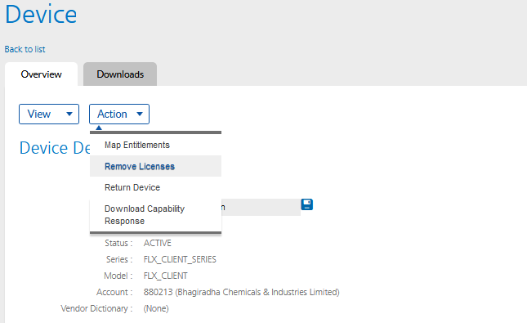

1. The Remove Licenses page will appear. The “Currently on Device” column shows the number of licenses for the Host ID. Put the amount you wish to remove on the “Qty to remove” field and click **Save:**

1. The status will change to “Waiting for confirmation”. The license will be cleared once you launch ChemDraw on the computer you want it removed from.

# Support

Our customer support organization is dedicated to helping you with any problems you may be having while downloading or using the software.

You can contact PerkinElmer Informatics Support via any of the methods listed on our Contact Page:   <http://informatics.perkinelmer.com/Support/Contact/>.

# End User License Agreement

**PERKINELMER INFORMATICS, INC.**

**CLICK-THROUGH LICENSE**

**AGREEMENT**

**PLEASE READ THIS AGREEMENT CAREFULLY**

This is a license agreement (“Agreement”) between PerkinElmer Informatics, Inc. (together with its affiliates and subsidiaries, “Licensor”), and you the recipient (“You”, “Your”) of a license to use the software with which this Agreement is provided and accompanying documentation (“Software”). This Agreement will prevail over any other terms or conditions regarding Your use of the Software except for an agreement signed by Licensor that specifically refers to the Software. Licensor is willing to grant You the following license to use the Software on the following terms.

**BY CLICKING ON THE “ACCEPT” BUTTON BELOW, YOU AND YOUR EMPLOYER (IF APPLICABLE) REPRESENT AND WARRANT THAT YOU HAVE READ THIS AGREEMENT, UNDERSTAND IT, AND AGREE (AND HAVE THE AUTHORITY ON BEHALF OF YOUR EMPLOYER TO AGREE) TO BE BOUND BY IT.**

**IF YOU DO NOT AGREE TO THE TERMS BELOW, LICENSOR IS UNWILLING TO LICENSE THE SOFTWARE TO YOU. IN THIS CASE, YOU SHOULD CLICK ON THE “DO NOT ACCEPT” BUTTON BELOW TO DISCONTINUE INSTALLATION.**

1. License. Subject to the terms of this Agreement, You may install and use one copy of the Software in executable code only, on one main computer You own or control and one home computer or laptop so long as only one copy of the Software is in use at any given time. You may also copy the Software for backup purposes, but only if You reproduce all copyright and other proprietary notices that are on the original copy. The foregoing rights are personal to You, non-exclusive, non-transferable and revocable.

2. Restrictions. You may not use, copy, modify, or transfer the Software, or any copy, in whole or in part, except as expressly provided in this Agreement. You may not reverse engineer, disassemble, decompile, or translate the Software, or otherwise attempt to derive its source code, or authorize any third party to do any of the foregoing. You may not remove, modify or obscure any proprietary notices on the Software. You may not (i) rent, lease, loan, resell for profit, transmit or distribute the Software; (ii) install the Software on more than one computer, except as expressly provided in this Agreement; (iii) use the Software on more than one computer simultaneously; (iv) use in a networked or multiple-user arrangement; or (v) use the Software to provide outsourcing, service bureau, online services or training to a third party.

3. Security Mechanisms. Licensor and its affiliated companies take all legal steps to eliminate piracy of its software products. The Software may include a security mechanism which collects and transmits usage data for the purpose of detecting the installation or use of illegal copies of the Software. Data collected will not include any customer data created with the Software. Upon Acceptance, You consent to such detection and collection of data, as well as its transmission and use. Licensor also reserves the right to use a hardware lock device, license administration software, and/or a license authorization key to control access to the Software. You may not take any steps to avoid or defeat the purpose of any such measures. Use of the Software by You without the required lock device or authorization key provided by Licensor is strictly prohibited.

4. Ownership. The Software is licensed, not sold, to You subject to the terms of this Agreement. Licensor reserves all rights not expressly granted to You. You own the media, if any, on which the Software is recorded, but Licensor retains ownership of all copies of the Software itself. You acknowledge that the Software contains and embeds valuable, unpublished information that is proprietary and confidential to Licensor and its licensors and suppliers. You agree to keep all such information confidential. This does not preclude You from using information You lawfully obtain from another source.

5. Use of Accessible Data; Non-Licensor Add-In. To the extent the Software contains, or provides remote access to, any images, photographs, animations, video, audio, music, text, “applets,” databases and data files (the “Accessible Data”), such Accessible Data is owned by Licensor or its licensors and suppliers and protected by United States copyright laws and international treaties. Other trademarks and copyrights are the property of their respective holders. The Accessible Data is solely for Your own internal use. You may not copy, distribute, reproduce or otherwise make publicly available the Accessible Data. Any violation of this provision shall be a breach of this Agreement and may result in a revocation of access to the Accessible Data, termination of this Agreement and civil or criminal penalties. The Software may also permit You to access, download, add, or use certain software add-ins, content, features, or technology, whether created or built by You or obtained from a third party or public source, into or within the Software (collectively, “Non-Licensor Add-In”). You must comply with all terms, conditions, restrictions or other obligations pertaining to Your access to, download, or use of the Non-Licensor Add-In(s). You are solely responsible and liable for, and Licensor hereby expressly disclaims all responsibility and liability for, (i) any security vulnerabilities and the consequences of such vulnerabilities arising from Your accessing, downloading, adding, or using any Non-Licensor Add-In, including, without limitation, in the event Your Internet access or any Non-Licensor Add-In contains any virus, malicious code, Trojan horse, worms, or other programming routines that could limit or harm the functionality of Your computer or that could damage, intercept or expropriate data, and (ii) any other issues, problems or damages arising from Your access to, or download, addition or use of, any Non-Licensor Add-In, including, without limitation, any damage to or impairment of the Software. All access to and use of Non-Licensor Add-In is at Your sole risk.

6. Term. This Agreement and Your license rights start on the date You accept this Agreement and download the Software, and will continue until terminated. Where You have paid a license fee for the Software, this Agreement shall continue for the term of the license subscription as set forth in the purchase order for which the license fee was paid unless earlier terminated in accordance with the terms of this Agreement. This Agreement will terminate immediately without notice to You if You materially breach any term or condition of this Agreement. You also may terminate this Agreement and Your licenses at any time, by destroying the Software and all copies thereof. Upon any termination, the license granted to you shall immediately cease and You agree to discontinue all use of the Software, promptly erase all copies of the Software and portions thereof from Your computer storage or any other media, and return or destroy all copies of the Software. Termination is not an exclusive remedy.

7. Limited Warranty. Licensor’s sole warranty with respect to the Software is that it shall be free of errors in program logic or documentation, attributable to Licensor, which prevent the performance of the principal computing functions of the Software. Licensor warrants this for a period of thirty (30) days from the date of receipt of the Software.

8. Warranty Disclaimer. TO THE MAXIMUM EXTENT PERMISSIBLE UNDER APPLICABLE LAW, LICENSOR DISCLAIMS ALL OTHER WARRANTIES OF ANY KIND, EXPRESS, IMPLIED OR STATUTORY, INCLUDING WITHOUT LIMITATION THE IMPLIED WARRANTIES OF MERCHANTABILITY, FITNESS FOR A PARTICULAR PURPOSE, TITLE AND NON-INFRINGEMENT, OR ANY IMPLIED WARRANTIES ARISING FROM COURSE OF DEALING OR COURSE OF PERFORMANCE. Some jurisdictions do not allow the exclusion of implied warranties, so the above disclaimer may not apply.

9. Limitation of Liabilities. Licensor’s entire liability and Your sole and exclusive remedy shall be, at Licensor’s sole discretion, either (A) the return of any license fee paid for the Software, or (B) correction or replacement of the Software that does not meet the terms of this limited warranty and that is returned to Licensor with a copy of Your purchase receipt. REGARDLESS OF WHETHER ANY REMEDY SET FORTH HEREIN FAILS OF ITS ESSENTIAL PURPOSE OR OTHERWISE, IN NO EVENT WILL LICENSOR OR ITS LICENSORS OR SUPPLIERS BE LIABLE TO YOU OR ANY THIRD PARTY UNDER ANY LEGAL THEORY OF LIABILITY FOR ANY LOSS OF PROFITS OR REVENUE, LOSS OR INACCURACY OF DATA, INTERRUPTION OF BUSINESS, COST OF SUBSTITUTION, OR ANY OTHER INDIRECT, SPECIAL, CONSEQUENTIAL, EXEMPLARY OR INCIDENTAL DAMAGES OF ANY NATURE ARISING OUT OF THE USE OR INABILITY TO USE THE SOFTWARE, EVEN IF LICENSOR HAS BEEN ADVISED OF THE POSSIBILITY OF SUCH DAMAGES AND WHETHER OR NOT SUCH DAMAGES ARE FORESEEABLE. IN NO EVENT WILL LICENSOR BE LIABLE FOR ANY LOSS OF PROFITS OR REVENUE, LOSS OR INACCURACY OF DATA, INTERRUPTION OF BUSINESS, COST OF SUBSTITUTION, OR ANY OTHER DIRECT, INDIRECT, SPECIAL, CONSEQUENTIAL, EXEMPLARY OR INCIDENTAL DAMAGES OF ANY NATURE ARISING OUT OF YOUR ACCESSING, DOWNLOADING, ADDING, OR USING ANY NON-LICENSOR ADD-IN. IN NO EVENT WILL THE LIABILITY OF LICENSOR OR ITS LICENSORS OR SUPPLIERS EXCEED THE GREATER OF ONE U.S. DOLLAR OR THE LICENSE FEE RECEIVED BY LICENSOR FROM YOU FOR THE SOFTWARE. Some jurisdictions do not allow the exclusion or limitation of liability for consequential or incidental damages, so the above exclusion may not apply.

10. U.S. Government End Users. If You represent a branch or instrumentality of the United States Government, the following provision applies. Each of the components that constitute the Software and its related documentation is a “commercial item” as that term is defined at 48 C.F.R. 2.101, consisting of “commercial computer software” and “commercial computer software documentation” as such terms are used in 48 C.F.R. 12.212. Consistent with 48 C.F.R. 12.212 and 48 C.F.R. 227.7202-1 through 227.7202-4, all U.S. Government end users acquire the Software and any documentation provided with the Software with only those rights set forth in this Agreement.

11. Export Law. The Software is subject to U.S. export control laws and may be subject to export or import regulations in other countries. You agree to strictly comply with all such laws and regulations, including but not limited to, the prohibition on use of the Software for: (1) development, production, handling, operation, maintenance, storage, detection, identification or dissemination of chemical, biological or nuclear weapons; and (2) nuclear explosive activities, unsafeguarded nuclear activities or nuclear fuel-cycle activities (whether safeguarded or unsafeguarded). You acknowledge that You have the responsibility to obtain any required export, re-export, or import licenses. You agree to indemnify and hold Licensor harmless from all claims, losses, liabilities, damages, fines, penalties, costs and expenses relating to Your breach of these obligations.

12. General.

• This Agreement will be governed by the laws of the Commonwealth of Massachusetts, without giving effect to conflict of laws principles that require the application of the laws of any other jurisdiction. The UN Convention on Contracts for the International Sale of Goods will not apply to this Agreement. You hereby irrevocably submit to the personal jurisdiction and venue of, and agree to service of process issued or authorized by, state and federal courts with jurisdiction over Suffolk County, Massachusetts, and You waive any objection thereto. The prevailing party in any action under this Agreement is entitled to receive its costs and expenses, including reasonable attorneys’ fees, incurred in that action, in addition to any other relief it may receive.

• If any provision is adjudged to be invalid or unenforceable by a court of competent jurisdiction, that provision will be removed and a suitable and equitable substitute provision shall be inserted. The remaining provisions will remain in full force. All waivers must be in writing. A party’s consent to, or waiver of, enforcement on one occasion will not be deemed a waiver of any other provision or such provision on any other occasion.

• You may not assign or delegate this Agreement, nor any rights or duties hereunder, in whole or in part, without Licensor’s prior written approval, which may be withheld in its sole discretion, and any purported attempt to do so is void.

• Only a subsequently dated written amendment referencing this Agreement and executed and delivered by both parties can modify this Agreement.

• This Agreement is the complete, exclusive and final agreement between You and Licensor; it supersedes, replaces and merges all prior and contemporaneous agreements, communications and understandings.

THE SOFTWARE IS PROTECTED BY UNITED STATES COPYRIGHT LAW AND INTERNATIONAL TREATY. UNAUTHORIZED REPRODUCTION OR DISTRIBUTION IS SUBJECT TO CIVIL AND CRIMINAL PENALTIES.

1. 10 launches cover an expected usage of one trial activation per business day for two weeks.